

Milestone 1

Ahmed Siddiqui, Tom Condon, Andrew Feng

Table of Contents

Milestone 1

Introduction…………………………………………....…………………………………………..3

1.0 System Planning and Selection…………………………………………......…………………4

1.1 Service Request Form…………………………………………………………………4

1.2 Scenario……………………………………………………………………………….6

1.2.1 Describing the Project Scope…………………………………………..........6

1.2.2 Describing the Project Alternatives………………………………...……….6

1.2.3 Describing the Project Feasibility…………………………………………...7

1.2.3.1 Economic Feasibility…………………………………....…….......7

1.2.3.2 Operation Feasibility ……………………………………………...7

1.2.3.3 Technical Feasibility…………………………………………........7

1.2.3.4 Schedule Feasibility ……………………………………….……...7

1.2.3.5 Legal and Contractual Feasibility………….……………………...7

1.2.3.6 Political Feasibility……………………………………………......7

1.3 Dividing the Project into Manageable tasks and Gantt Chart…………………………8

1.4 Estimating Tangible Cost and Benefits and Creating a Preliminary Budget………...10

1.5 Calculating ROI (%), Break-even, and Break-even Chart…………………………...12

1.6 Developing a Communication Plan…………………………………………….........13

1.7 Determining Project Standards and Procedures……………………………………...14

1.8 Identifying and Assessing Risk………………………………………………………14

1.9 Baseline Project Plan…………………………….…………………………………..14

1.10 Preparing a Project Scope Statement…………………………………………….…15

2.0 User Requirements ……………………………………………………………………..........16

3.0 System Requirements………………………………………………………………………...16

**Introduction**

University of Massachusetts Lowell (UMass Lowell) is a State University in Massachusetts, Lowell. It is a part of the UMass system of schools located around Massachusetts, namely UMass Amherst, UMass Boston, UMass Dartmouth, UMass Lowell, and UMass Medical. UMass Lowell was created in 1972 when Lowell State College and Lowell Technological Institute joined hands to work together to offer more and mixed opportunities to their students.

UMass Lowell is a well-known university for its value filled education, staff, accreditations, and love of sports. It is one of the very first and few Universities to have its Business School be accredited by the Association to Advance Collegiate Schools of Business International. UMass Lowell is a university that has continued to grow as more students enroll for wide arrangements of bachelor’s, master’s, and doctoral degrees.

With the recent return to campus from the Covid-19 pandemic students will also resume living on campus or near campus, with that comes the issue of the dining halls and overcrowding in the dining halls. Currently the only way for students to make use of the meal plan is to walk into the dining hall, order food from the counter or grab the ready food under the warmers and eat while seated in the dining hall. Being forced to dine at the dining hall makes it hard for students who are in between classes or running late.

With the new system in place students will be able to order food at the dining hall and have it ready by the time they come in and be able to pick it up and take it wherever they go, whether it be to their next class, to their team project meeting location, to their dorm, or wherever else they may need to go if they don't have the time to spend in the dining hall itself.

**1.1 Service Request Form**

REQUESTED BY: Professor Edward T. Chen DATE: September 16, 2021

DEPARTMENT: Dining Hall

LOCATION: Lowell, University of Massachusetts

CONTACT: Tel (978)-934-2756

TYPE OF REQUEST

* System Enhancement

URGENCY

* Business Losses can be tolerated until the system enhancement is completed

PROBLEM STATEMENT

With the return of students after Covid-19, we need to improve the safety measures for students with meal plans returning to campus. There is currently no system for on the go ordering. With an on the go ordering system students will be able to avoid the crowding in the dining halls which will make complying with covid regulations easier.

SERVICE REQUEST

Requisition for a new system with capabilities to handle transactions in web format, Student Data, Food Data, Assist the management team with adding and removing items from the menu.

IS LIAISON: Ahmed Siddiqui, Tom Condon, Andrew Feng

SPONSOR: MIST.4020

_________TO BE COMPLETED BY SYSTEM PRIORITY BOARD___________

[ ] REQUEST APPROVED

START**:**

ASSIGNED TO**:**

[ ] RECOMMENDED REVISION

[ ] SUGGEST USER DEVELOPMENT

[ ] REJECT**:**

**1.2.1 Describing the Project Scope**

This project is going to design a new web-based system that will help students order food for “on the go” orders using RiverHawk Dollars that come with their Student Meal Plans. The web platform will handle online orders of the available items on the menu and take in student information. The database system will allow the managers or those in the position of authority to change the menu for that allotted day or time.

In all this system is going to make busy students or students who will have a hard time grabbing lunch during their tight schedule to be able to grab a meal before heading off to class, work, or meeting in the case that they may end up having to miss a meal and not enjoy what's available that day in the dining hall.

**1.2.2 Describing the Project Alternatives**

A possible alternative to this may be that students order at restaurants or cafes around campus. This is an alternative but it's not efficient for students as there would be increased weight times in each of these restaurants and it would require the students to utilize actual money apart from their RiverHawk Dollars or their meal plan. It would be much simpler for the students to be able to grab a fresh hot lunch from the dining hall as they leave for the main campus rather than run to one of the open and packed restaurants outside/around campus and grab their food. In the case that these restaurants have “on the go” ordering they are usually packed with other students and understaffed to be able to timely handle “on the go” ordering.

The issues that arise for these alternatives is that even if a restaurant or cafe were to hire more people to accommodate its influx of customers it would be hard to expand their borders/doors to accommodate the larger number of people because of the price of property near the ever-expanding campus. In the option that a restaurant or cafe was to expand its business it would require it to go under construction which would cause it to close its doors for a few days which could potentially push its customers to other nearby restaurants or cafes.

For UML’s “on the go” ordering the benefit is that a student can order at any of the campuses and go pick up their food. If a student for instance dorms or lives near south campus but needs to head to north campus for class or a meeting then they can order at the north or east dining halls, grab their food and go.

**1.2.3.1 Economic Feasibility**

Benefits

* Error Reduction
* Increase speed of activity
* Increase dining hall sales
* Improve dining hall service

Costs

* Training
* System Development
* Maintenance

**1.2.3.2 Operational Feasibility**

This system allows for the ability to avoid the overcrowding of the dining hall during peak hours and provide flexibility to customers with tight schedules. It allows the dining experience to be more efficient and stress free.

**1.2.3.3 Technical Feasibility**

The System requires certain tech skills such as HTML and CSS as it requires a development of a user interface.

**1.2.3.4 Schedule Feasibility**

The Gantt and Pert chart estimate that the project will be done in late March if the project is started as soon as possible. The school would like it to be completed as soon as possible so it can be used in the spring semester.

**1.2.3.5 Legal and Contractual Feasibility**

The team must be considerate of student’s sensitive information when developing the system and make sure security measures are in place.

**1.2.3.6 Political Feasibility**

The project is determined to have limited risk associated with this.

**1.3 Dividing the Project into Manageable tasks and Gantt Chart**

Gantt

|  |  |  |  |  |  |  |  |
| --- | --- | --- | --- | --- | --- | --- | --- |
| ID | Task Name | Duration | Start | Finish | Predecessors | Finish Slack | Critical |
| 1 | Requirements Collection | 3 wks | Mon 10/4/21 | Fri 10/22/21 |  | 0 wks | Yes |
| 2 | Web Design | 3 wks | Mon 10/25/21 | Fri 11/12/21 | 1 | 2 wks | No |
| 3 | Screen Design | 2 wks | Mon 10/25/21 | Fri 11/5/21 | 1 | 3 wks | No |
| 4 | Database Design | 4 wks | Mon 11/29/21 | Fri 12/24/21 | 3,2,5 | 0 wks | Yes |
| 5 | Security Design | 5 wks | Mon 10/25/21 | Fri 11/26/21 | 1 | 0 wks | Yes |
| 6 | User Documentation | 5 wks | Mon 12/27/21 | Fri 1/28/22 | 4 | 0 wks | Yes |
| 7 | Programming | 6 wks | Mon 1/31/22 | Fri 3/11/22 | 6 | 0 wks | Yes |
| 8 | Testing | 2 wks | Mon 3/14/22 | Fri 3/25/22 | 7 | 0 wks | Yes |
| 9 | Installation | 1 wk | Mon 3/28/22 | Fri 4/1/22 | 8 | 0 wks | Yes |

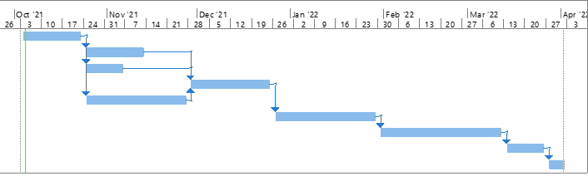

**Pert**

|  |  |  |  |  |  |
| --- | --- | --- | --- | --- | --- |
| Activity | Optimistic | Realistic | Pessimistic | Estimated Time  (O+4R+P)/6 | Preceding Activity |
| Requirements Collection | 2 | 3 | 4 | 3 | - |
| Web Design | 2 | 3 | 4 | 3 | 1 |
| Screen Design | 1 | 2 | 3 | 2 | 1 |
| Database Design | 3 | 4 | 5 | 4 | 2,3,5 |
| Security Design | 4 | 5 | 6 | 5 | 1 |
| User Documentation | 4 | 5 | 6 | 5 | 4 |
| Programming | 5 | 6 | 7 | 6 | 6 |
| Testing | 1 | 2 | 3 | 2 | 7 |
| Installation | 1 | 1 | 1 | 1 | 8 |

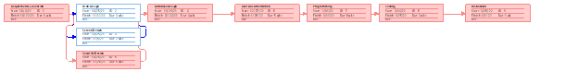

**Activity Slack Time**

|  |  |  |  |  |
| --- | --- | --- | --- | --- |
| Activity | TE | TI | Slack TE-TI | Critical Path |
| Requirements Collection | 3 | 3 | 0 | Yes |
| Web Design | 6 | 8 | 2 | No |
| Screen Design | 5 | 8 | 3 | No |
| Database Design | 12 | 12 | 0 | Yes |
| Security Design | 8 | 8 | 0 | Yes |
| User Documentation | 17 | 17 | 0 | Yes |
| Programming | 23 | 23 | 0 | Yes |
| Testing | 25 | 25 | 0 | Yes |
| Installation | 26 | 26 | 0 | Yes |

**1.4 Estimating Tangible Cost and Benefits and Creating a Preliminary Budget**

|  |  |  |
| --- | --- | --- |
| **Tangible Benefits** | | |
| **Umass Lowell system project** | | |
|  |  | Year 1 through 5 |
| A | Decrease Wait time | 15,750 |
| B | Increase flexibility | 2,000 |
| C | Error Reduction | 5,000 |
| D | Cost Reduction | 4,000 |
| E | Inventory | 2,500 |
| F | Other | 0 |
| Total Tangible Benefits | | 29,250 |

|  |  |  |
| --- | --- | --- |
| **One-Time Costs Worksheet** | | |
| **UMass Lowell system project** | | |
|  |  | Year 1 through 5 |
| A | System Development Costs | 9,500 |
| B | New Hardware | 3,300 |
| C | New Software | 4,200 |
| D | User Training | 2,500 |
| E | Station Preparation | 3,500 |
| F | Other | 0 |
| Total Tangible Benefits | | 23,000 |

|  |  |  |
| --- | --- | --- |
| **Recurring Cost Worksheet** | | |
| **UMass Lowell system project** | | |
|  |  | Year 1 through 5 |
| A | Application software maintenance | 6,000 |
| B | Supplies | 2,400 |
| C | Annual training | 4,050 |
| F | Other | 0 |
| Total Tangible Benefits | | 12,450 |

**1.5 Calculating ROI%, Break-even, and Break-Even Chart**

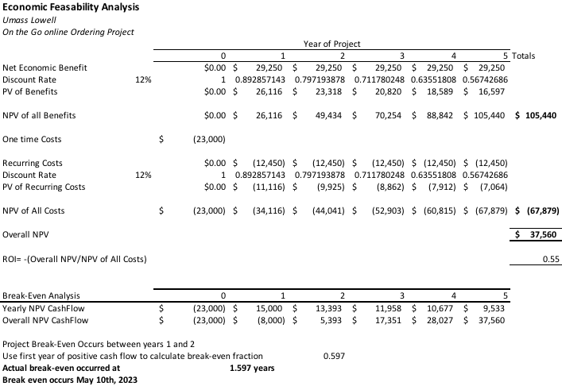

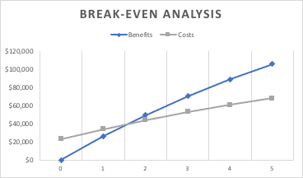

**1.6 Developing a Communication Plan**

|  |  |  |  |  |
| --- | --- | --- | --- | --- |
| Reason | Method | Objective | Members | Date |
| First Team Meeting | Face to Face | Get to know group members and understand each other's timetables | Team | Sept. 9, 2021 |
| System Analysis | Zoom Call | Analyzing the current limitations of the system in place and planning on the upgrades eligible for the current system | Team | First Monday of Month |
| Design Analysis | Zoom Call | Designing the layout plan for the system implementation. | Team | Third Monday of Month |
| Project Analysis | Zoom Call | Discussing the project schedule and discussing any additional complaints or issues | Team | First Monday of Month |
| Project Roundup | Zoom Call | Rounding up and testing the system to see if functional | Team, Stakeholders | Third Monday of Month |
| D-Day / Project Release | Zoom Call | Project assessment and implementation | Team | First Monday of Month |

**1.7 Project Standards and procedures**

To determine if the system is working up to standards, we will rely heavy on students' feedback. These feedbacks will be used to improve our system and ensure that our customers' satisfaction is high. The data collected from these feedbacks will be used to create a system that will be beneficial to both students and faculty.

**1.8 Identifying and Assessing Risks**

Our system features an online ordering service, and it requires customers to input their sensitive information such as credit cards and phone numbers. Since there is sensitive information involved, there is always a risk of unauthorized users attempting to steal it. Features such as requiring a username and password will greatly decrease this threat.

**1.9 Baseline Project Plan**

**Baseline Project Plan Report**

*Introduction*

1. **Project overview-** With the return of students onto the campus, the university is looking for a way to reduce capacity in the dining halls.
2. **Recommendation-** With an online “on the go” ordering system students can place orders for the dining hall and then walk to the dining hall to pick them up.

System Assessment

1. **Alternative-** Some project alternatives could be that students could order food from restaurants around campus. This would limit the amount of exposure on campus and reduce the system requirement for the university.
2. **System Description-** A new web program for the “on the go”ordering, so students can order food and pick it up at the dining halls.

Feasibility Assessment

1. **Economic Analysis-**

* Benefit- $29,250
* Recurring Cost- $12,450
* One Time Cost- $23,000
* ROI- 55%
* Overall NPV- $37,560

1. **Technical Analysis-** Employees with tech skills such as HTML and CSS as it requires a development of a user interface.
2. **Operational Analysis-** The proposed system would reduce the foot traffic in the dining hall in accordance to the covid 19 regulations.
3. **Legal and Contractual Analysis-** The team must be considerate of student’s personal information when developing the system and make sure security measures are in place.
4. **Political Analysis-** This project has no risk of political association.
5. **Schedule Analysis-** The project is estimated to be done in late March if the project is started as soon as possible. The school would like it to be completed as soon as possible so it can be used in the spring semester.

**Management Issues**

1. **Team Configuration and Management-** Ahmed, Andrew, and Tom will be tasked with completing this project. All roles and responsibilities will be split up evenly.
2. **Communication Plan-** All meetings for discussion along with the team will happen on Mondays.
3. **Project Standards and Procedures-** The milestones will be reviewed by a Project Sponsor who will be overseeing the project.

**1.10 Preparing a Project Scope Statement**

UMass Lowell Dining “on the go”

Project Scope Statement

*General Project Information*

**Project Name**: UMass Lowell Dining “on the go”

**Sponsor**: Edward Chen

**Project Manager**: Ahmed Siddiqui, Thomas Condon, Andrew Feng

*Problem/Opportunity Information*

UMass Lowell has over 15000 students and this opportunity provides a major convenience to the student, which in turn increases their satisfaction towards the dining experience. It also eases overcrowding in the dining hall during peak hours.

*Project Objectives*

The system will be created to provide the students with an easy and convenient way to order food. It allows the people that have a tight schedule to have a quick bite on the fly without the hassle of waiting in line.

*Business Benefits*

* Increase in Meal Plans Sales
* Online order and payments
* Increase customer satisfaction

*Project Deliverables*

* Website
* Software for online ordering
* Payment system

**2.0 User Requirements**

Through the system, users are able to create online orders and receive a notification when their orders are ready for pick up. A smart device such as a phone or laptop that has internet access is required in order to access the system.

**3.0 System Requirements**

Hardware: Display, Keyboard, Memory, Processor

Software: System Software (Windows, MAC OS , Linux), Programming Software (HTML, CSS, Python), Application Software (Microsoft Suite, Internet Browsers)